**PL3 ESE**

Name: Muskan Raju Attar

PRN: 2019BTECS00017

Batch: T1

Sub: Programming Lab 3

Design a website for Online Event Management with following objectives:\r\n Index/Home Page that shows website information, and login/registration option\r\n User Registration – Full Name, Mobile Number, Address, Email ID, password\r\n User login – Form for event registration\r\n Event Category (Wedding, Birthday, Anniversary, Other)\r\n Location/Place\r\n Date\r\n Expected Budget\r\n Food Type (Maharashtrian, Punjabi, Italian, Spanish)\r\n Number of Attendees\r\n Contact us Page\r\n Every page should be responsive\r\n Provide all validations\r\n Use styles to make it attractive\r\nLink all pages using navigation bar\r\n Use appropriate HTML elements and CSS properties\r\n Host website on any free web hosting service and upload the source code GitHub public repository

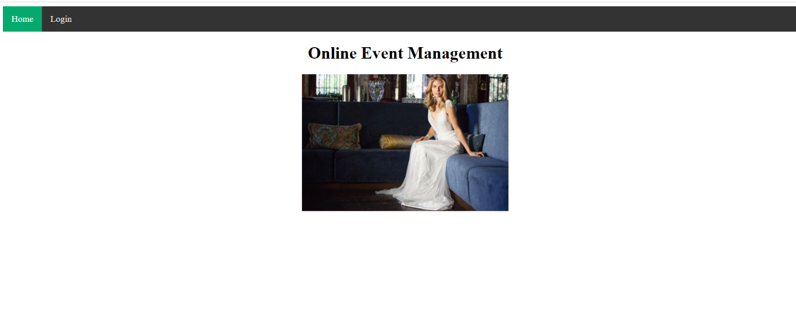

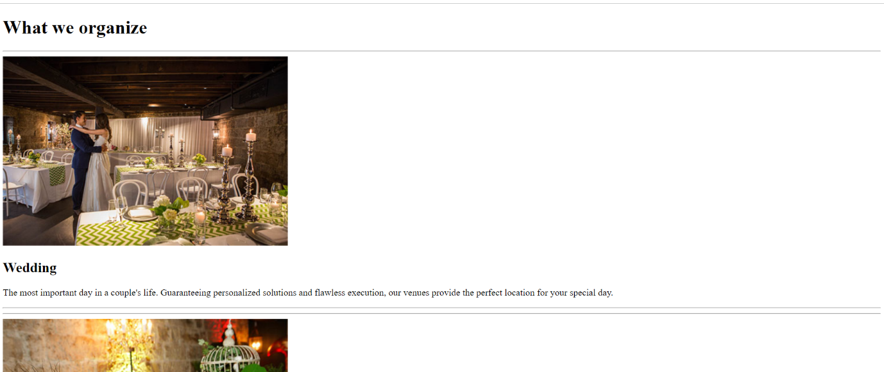



Host link:

https://muskan788.github.io/2019BTECS00017PL3-ESE-lab/